**1. Which customers live in New Jersey? List each customer’s last name, first name, and state.**

SELECT customer#, lastname, firstname, state

FROM "CUSTOMERS"

WHERE State = 'NJ';

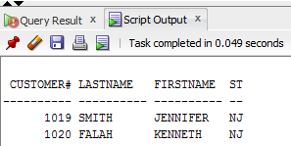

**2. Which orders shipped after April 1, 2009? List each order number and the date it shipped.**

SELECT order#, shipdate

FROM "ORDERS"

WHERE SHIPDATE > '1-APR-09'

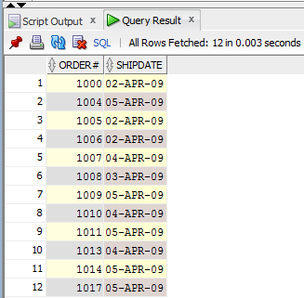

**3. Which books aren’t in the Fitness category? List each book title and category.**

SELECT title,

category FROM "BOOKS"

WHERE Category <> 'Fitness'

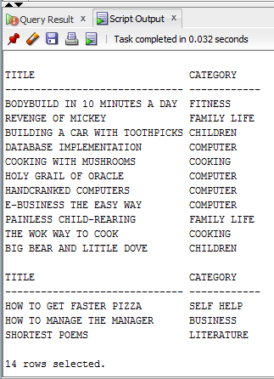

**4. Which customers live in Georgia or New Jersey? Put the results in ascending order by last name. List each customer’s customer number, last name, and state. Write this query in two different ways.**

SELECT customer#, lastname, state

FROM "CUSTOMERS"

WHERE state = 'GA' OR State= 'NJ'

ORDER BY lastname;

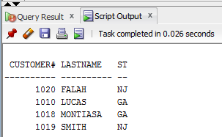

SELECT customer#, lastname, state

FROM "CUSTOMERS"

WHERE state = 'GA' OR State= 'NJ'

ORDER BY lastname DESC;

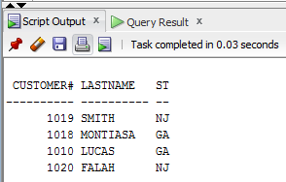

**5. Which orders were placed on or before April 1, 2009? List each order number and order  
date. Write this query in two different ways.**

SELECT order#, orderdate

FROM "ORDERS"

WHERE SHIPDATE <= '1-APR-09'

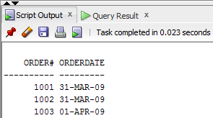

SELECT order#, orderdate

FROM "ORDERS"

WHERE SHIPDATE <= '1-APR-09'

ORDER BY orderdate DESC;

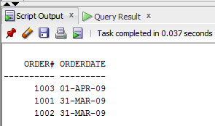

**6. List all authors whose last name contains the letter pattern “IN.” Put the results in order of last name, then first name. List each author’s last name and first name.**

SELECT lname, fname

FROM "AUTHOR"

WHERE lname LIKE '%IN%'

ORDER BY lname, fname;

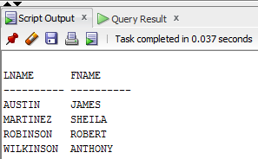

**7. List all customers who were referred to the bookstore by another customer. List each  
customer’s last name and the number of the customer who made the referral.**

SELECT lastname, referred

FROM customers

WHERE referred IS NOT NULL

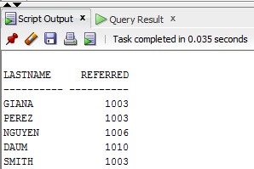

**8. Display the book title and category for all books in the Children and Cooking categories.  
Create three different queries to accomplish this task: a) a search pattern operation, b) a  
logical operator, and c) another operator not used in a or b.**

a.

SELECT title, category

FROM books

WHERE category LIKE 'CHILDREN' OR category LIKE 'COOKING';

b.

SELECT title, category

FROM books

WHERE category = 'CHILDREN' OR category = 'COOKING';

c. SELECT title, category

FROM books

WHERE category IN ('CHILDREN', 'COOKING');

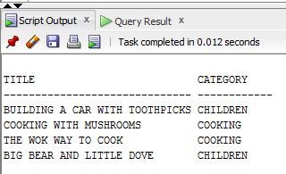

**9. Use a search pattern to find any book title with “A” for the second letter and “N” for the  
fourth letter. List each book’s ISBN and title. Sort the list by title in descending order.**

SELECT isbn, title

FROM books

WHERE title LIKE '_A_N%'

ORDER BY title DESC;

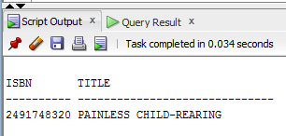

**10. List the title and publish date of any computer book published in 2005. Perform the task of searching for the publish date by using three different methods: a) a range operator, b) a logical operator, and c) a search pattern operation.**

a.

SELECT title, pubdate

category FROM "BOOKS"

WHERE category = 'COMPUTER' AND pubdate BETWEEN '01-JAN-05' AND '31-DEC-05';

b.

SELECT title, pubdate

category FROM "BOOKS"

WHERE category = 'COMPUTER' AND pubdate <= '31-DEC-05' AND pubdate >= '01-JAN-05';

c.

SELECT title, pubdate

category FROM "BOOKS"

WHERE category = 'COMPUTER' AND pubdate LIKE '%05%';

